In this Lab we will create a schedule at App engine service using Cloud Schedular service

Go to GCP console and search for cloud schedular

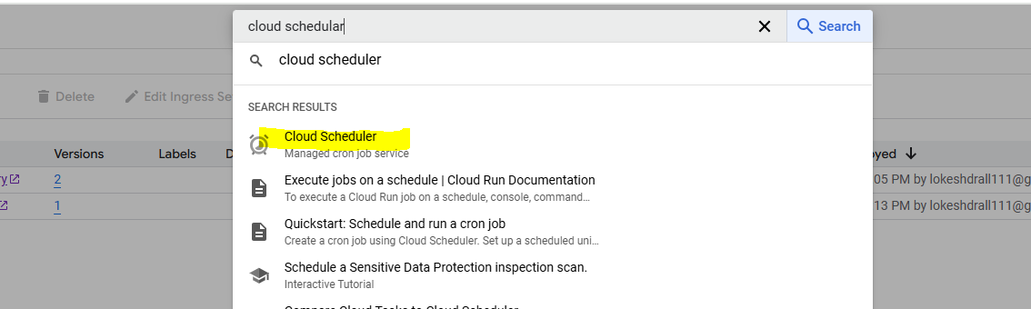

Enable API if asked

Click create job

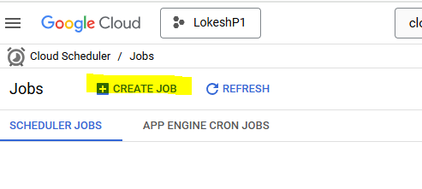

Enter name and frequency (for help regarding frequency format for cron job, you can take help from website <https://crontab.cronhub.io/> )

Enter 0 0 \* \* \* at frequency ( this can also be tested on above mentioned website)

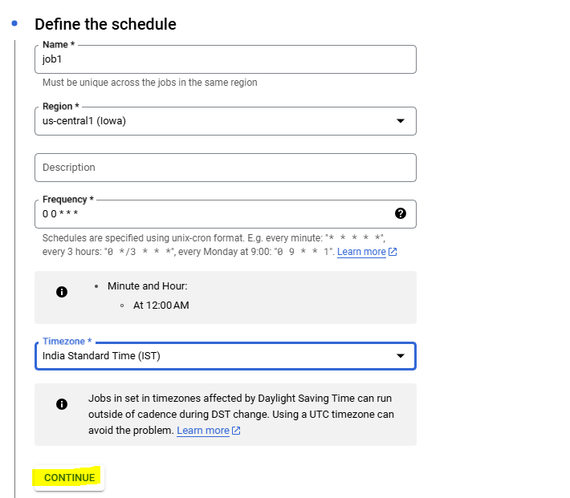

Fill the details related to the app engine

